**2017-2018 EDUCATION YEAR TİCARET ODASI PRIMARY SCHOOL 2nd TERM**

**2nd ENGLISH WRITTEN EXAM OF 4th GRADES**

Name & Surname : ____________________________________ Number:_________ Class: 4/A

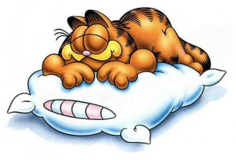A.Choose the correct answer ( 25x 4=100points)

He is lazy

**1)**

|  |  |  |  |
| --- | --- | --- | --- |
| **A)** She’s friendly. | | **B)** She is bald. | |
| **C)** She’s lazy. | | **D)** She is hardworking. | |

**2**) What is he like?

**A)** He is friendly. **B)**He is tall.

**C)**He is shy. **D)**He is fat.

**3) Aşağıda verilen bilgilere göre Efe’nin babası hangi görseldedir?**



A)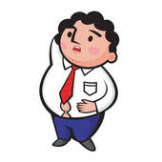B) C)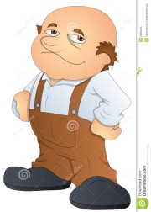 D)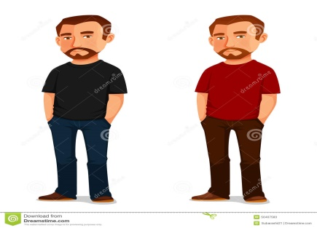

**4) Görsele uygun cümleyi seçiniz.**

|  |
| --- |
| 1. She has got short blonde hair and green eyes.   She is short and fat. |
| 1. She has got short brown hair and blue eyes.   She’s tall and slim. |
| **C)** She has got long straight blonde hair and  brown eyes. She is short and heavy. |
| **D)** She has got wavy brown hair and green eyes.  She’s ugly and fat. |

**5)**

**Görselin yanındaki cevabı verebilmemiz için hangi soruyu sormalıyız?**

**A)** What is his job?

**B)** Where does he work?

**C)** What does he look like?

**D)** What is he like?

**6)** 

A) long B) straight

C) curly D) white

**7) Yandaki görselde**

**işaretlenen bayanı**

**tanımlayan cümle**

**hangisidir?**

**A)** She is short. **B)**She is tall.

**C)** She is fat. **D)**She is of medium height.

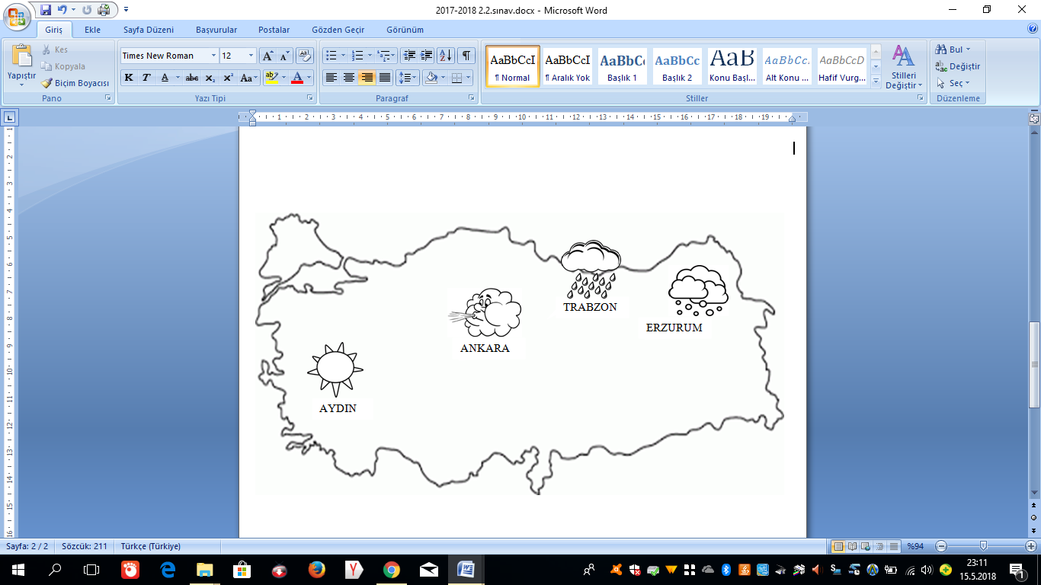

**8,9,10 ve 11. soruları yukarıdaki görsele göre cevaplayın.**

**8) What is the weather like in AYDIN? It's...**

**A) sunny B) windy C) rainy D) snowy**

**9) What is the weather like in ANKARA? It's...**

**A) foggy B) windy C) rainy D) snowy**

**10) What is the weather like in TRABZON? It's...**

**A) sunny B) thundery C) rainy D) snowy**

**11) What is the weather like in ERZURUM? It's...**

**A) sunny B) windy C) rainy D) snowy**

**12) It is March . What season is it? It's...**

**A) It is summer B) It is winter**

**C) It is autumn D) It is spring.**

**13)**

**Boşluğa hangi ay adı yazılmalıdır?**

**A) January B) October C) June D) May**

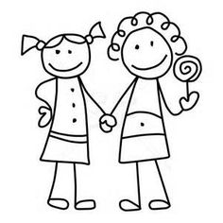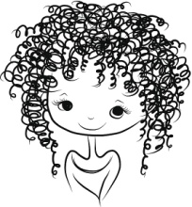

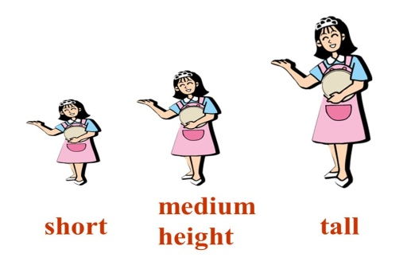

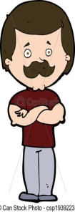

September - ????? - November - December

20) **How many SEASONS are there in a year?**

**A) 12 B) 4 C) 8 D) 365**

**21) How many MONTHS are there in a year?**

**A) 12 B) 4 C) 8 D) 365**

**22)**

**23)**

**24) Görseldeki kişi aşağıdaki soruyu nasıl cevaplamış olabilir?**

**A) It's cold and snowy.**

**B) It's hot and sunny**

**C) It's warm and rainy**

**D)It's cool and windy.**

**25) Aşağıdaki resim-kelime eşleştirmelerinden hangisi yanlıştır?**

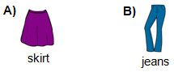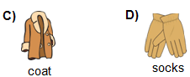

**GOOD LUCK!**

**14) Aşağıdaki tablolar eşleştirildiğinde hangi sonuç ortaya çıkar?**

|  |  |
| --- | --- |
| **1** | **pilot** |
| **2** | **vet** |
| **3** | **farmer** |

|  |  |
| --- | --- |
| **a** | **milk cows** |
| **b** | **help animals** |
| **c** | **Fly planes** |

**15) Aşağıdaki boşlukları sırasıyla hangi seçenekteki bilgiler ile doldurmalıyız?**

**1. A doctor works at a ..........**

**2. A policeman works at a.......**

**3.A chef works at a ......**

**A) hospital , farm , restaurant**

**B) hospital , police station , restaurant**

**C) school , fire station , farm**

**D) theatre , restaurant , school**

**16) Yandaki görsele**

**hangi soru sorulmuş**

**olabilir?**

**17) . Aşağıda resimleri verilen kıyafetlerin isimlerinin bulunduğu seçeneği işaretleyiniz.**

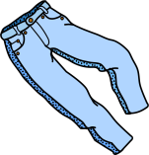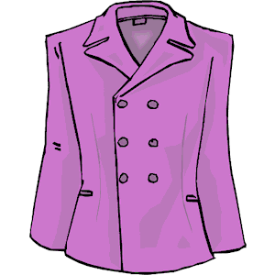

|  |  |
| --- | --- |
| **A)** jeans-coat –shoes- scarf | **B)** shorts-shirt-boots-hat |
| **C)** jeans-jacket-shoes-hat | **D)** jeans-skirt-shoes-coat |

**18)**

**Yukarıdaki cümleye aşağıdakilerden hangisi YAZILAMAZ?**

**A) sunglasses B) shorts**

**C) T-shirt D) boots**

**19) What are the months of SUMMER?**

**A) June , July , August**

**B) March , April , May**

**C) January , February , March**

**D) December , January , February**

A) 1-c , 2-a , 3-b

B) 1-a , 2-c , 3-b

C) 1-c , 2-b , 3-a

D) 1-b , 2-a , 3- c

It's rainy .Take your ...........

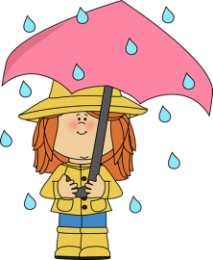

A) sunglasses

B) hat

C) skirt

D)umbrella

**?**

May I borrow your

sunglasses?

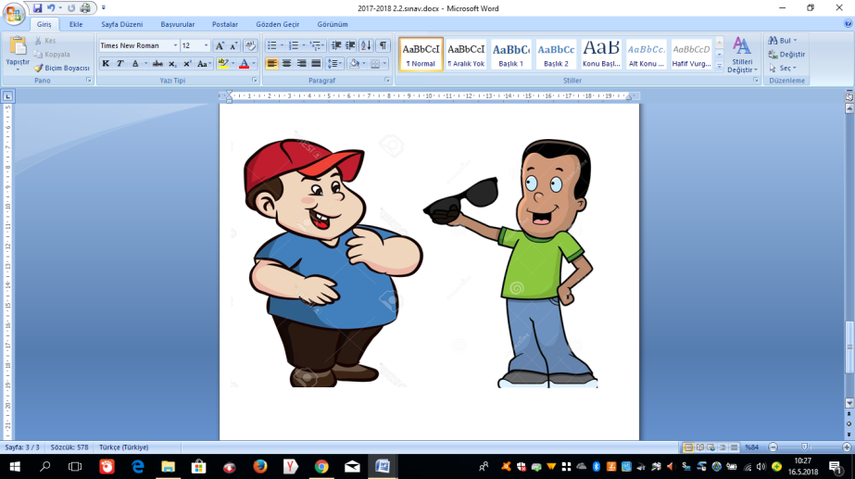

**Soru işareti yerine aşağıdakilerden hangisini söylemiştir?**

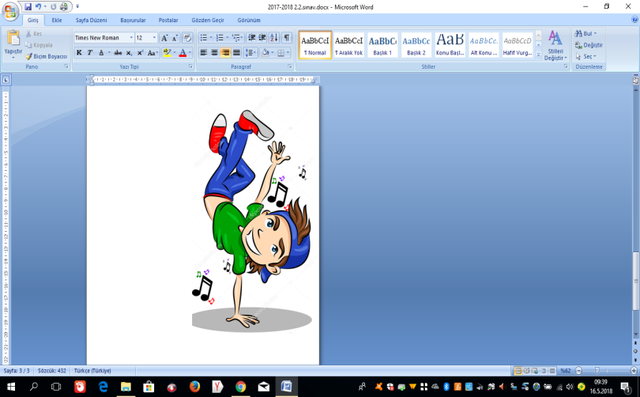

I'm a dancer

A)What is your job?

B) Where do you work?

C) What do you like?

D) What is he like?

A) I'm sorry , it is broken.

B) Sorry , I need it.

C)Here you are.

D) I'm sorry ,not right now.

?

**What is the weather like in WINTER?**

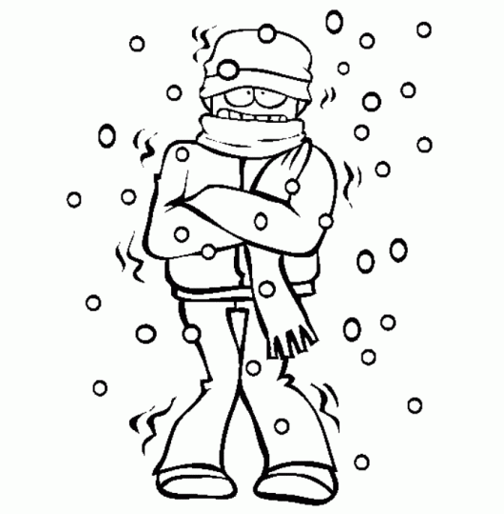

**I need .....in summer.**

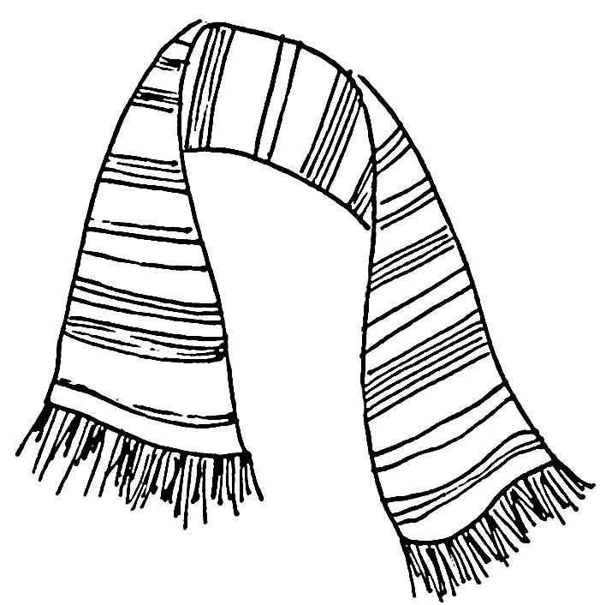

scarf

