İNGİLİZCE DENEME
6.
SINIF

1. Hangi öğrencinin cümlesi yanlıştır?

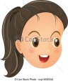
A)
We should use public transportation.

Doğa
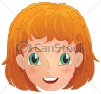
B)
We shouldn’t throw our rubbish around.

Simge
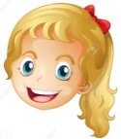
We shouldn’t clean up after picnic.
C)

Ecem
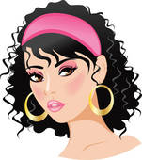
D)
We shouldn’t damage trees.

Beril

(2. 3. 4. ve 5. soruları verilen paragrafa göre cevaplayınız.)
The Bank Robbery
It was 9.30 a.m. The bank wasn’t crowded.
I was in front of the window. Suddenly a man with mask entered the bank. The robber was tall and thin. He had a gun in his hand. He put the money in a black briefcase. Then, he ran out of the bank quickly. I think he went away by a car. I couldn't see it, but I heard the noise.

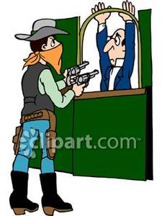

2. Was the bank crowded?

A) No, she didn’t. | B) No, it wasn’t.
C) Yes, it was. | D) At the bank.

3. When did the robbery happen?

A) At half past nine a.m. | B) By a car.
C) Tall and thin. | D) A mask.

4. Did the robber have a knife in his hand?

A) Yes, he was. | B) Yes, I did.
C) No, he didn’t. | D) No, she isn’t.

5. How did the robber go away?

A) In a black briefcase. | B) By a car.
C) He had a gun. | D) I heard a noise.

6. Aşağıdaki boşluğa uygun kelime hangi seçenektedir?
Yesterday was Tuesday.Today is_________.

A) Monday | B) Thursday | C) Wednesday | D) Friday

7. Aşağıdaki önerilerden hangisi yanlıştır?
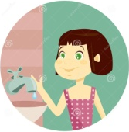
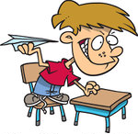
A)  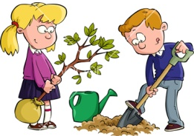  He should waste paper. | B)  She should turn off the tap.  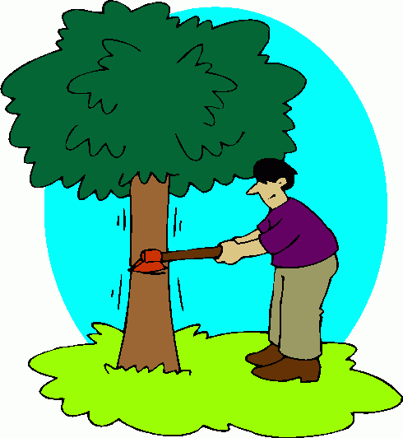
C) | D)

They should plant trees He shouldn’t cut down trees

8. Aşağıdaki eşleştirmelerden hangisi yanlıştır?
A) three hundred and ninety four 394

B) sixty five thousand eight hundred and one 65 108

C) seventeen thousand and ten 17 010

D) two thousand and fourteen 2014

9. Hangi kelimenin görseli yanlış verilmiştir?

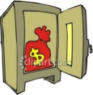
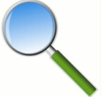
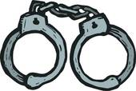
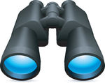
A) | B) | C) | D)

Safe drawer handcuffs magnifier

10. Aşağıdaki cümlelerdeki boşlukları sırasıyla doldurunuz.
- We_____make fire in the forest.
- We_____unplug the TV.
- We_____use our family car too often.
- We_____destroy forests.
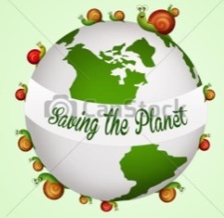

A) should- shouldn’t- shouldn’t- shouldn’t
B) shouldn’t- should- shoudn’t- shouldn’t
C) shouldn’t- shouldn’t- should- should
D) shouldn’t- should- shouldn’t- should

